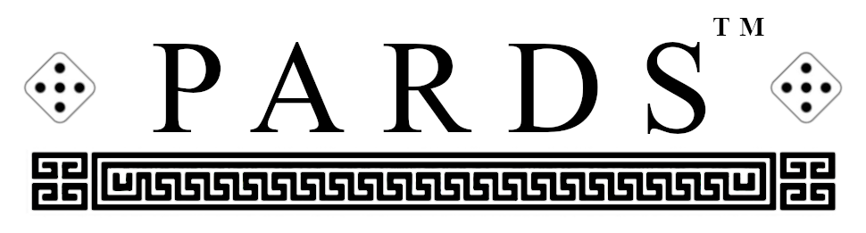
Derived from the word ‘leopards’—due to its pip-spotted playing board—Pards is a strategy game of shifting tombstones, sudden snares, terrifying traps and perilous pitfalls. The dice are rolled before the game pieces are set up and are never rolled again during play. Games are played in sets of two games; after the first game, the players switch sides and the dice are reset to the numbers that were set at the beginning of the first game. The dice, therefore are only rolled once every two games.
Goal: The goal of the game is to move the Vicar game piece to the last rank on your opponent’s side of the board. This means that for White to win he must bring the Vicar to the 7th rank and that for Black to win he must bring the Vicar to the 1st rank. There is one Vicar and four suits of pieces:
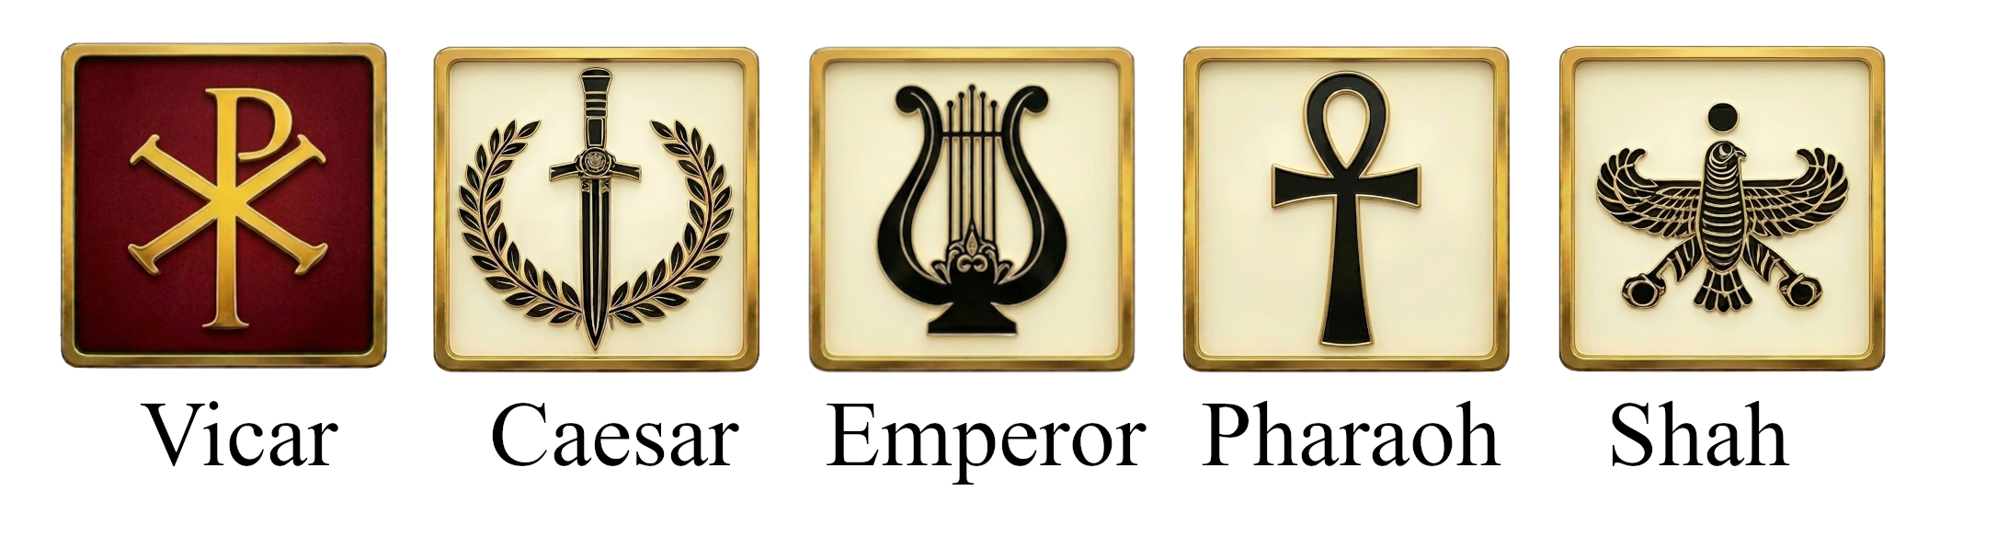
Each player has one Caesar, two Emperors, three Pharaohs, and four Shahs.
Ownership: The white pieces are moved by White and the black pieces are moved by Black. Each time a sack occurs the Vicar may be moved by the player who successfully executed the sack. The player who moves the Vicar may be White or Black.
Set up: Both players roll their dice. Doubles are rerolled. Players next place one die next to each of their two corners with the lowest number on the left. Players next set up their game pieces within their respective territories as seen in the given diagram:
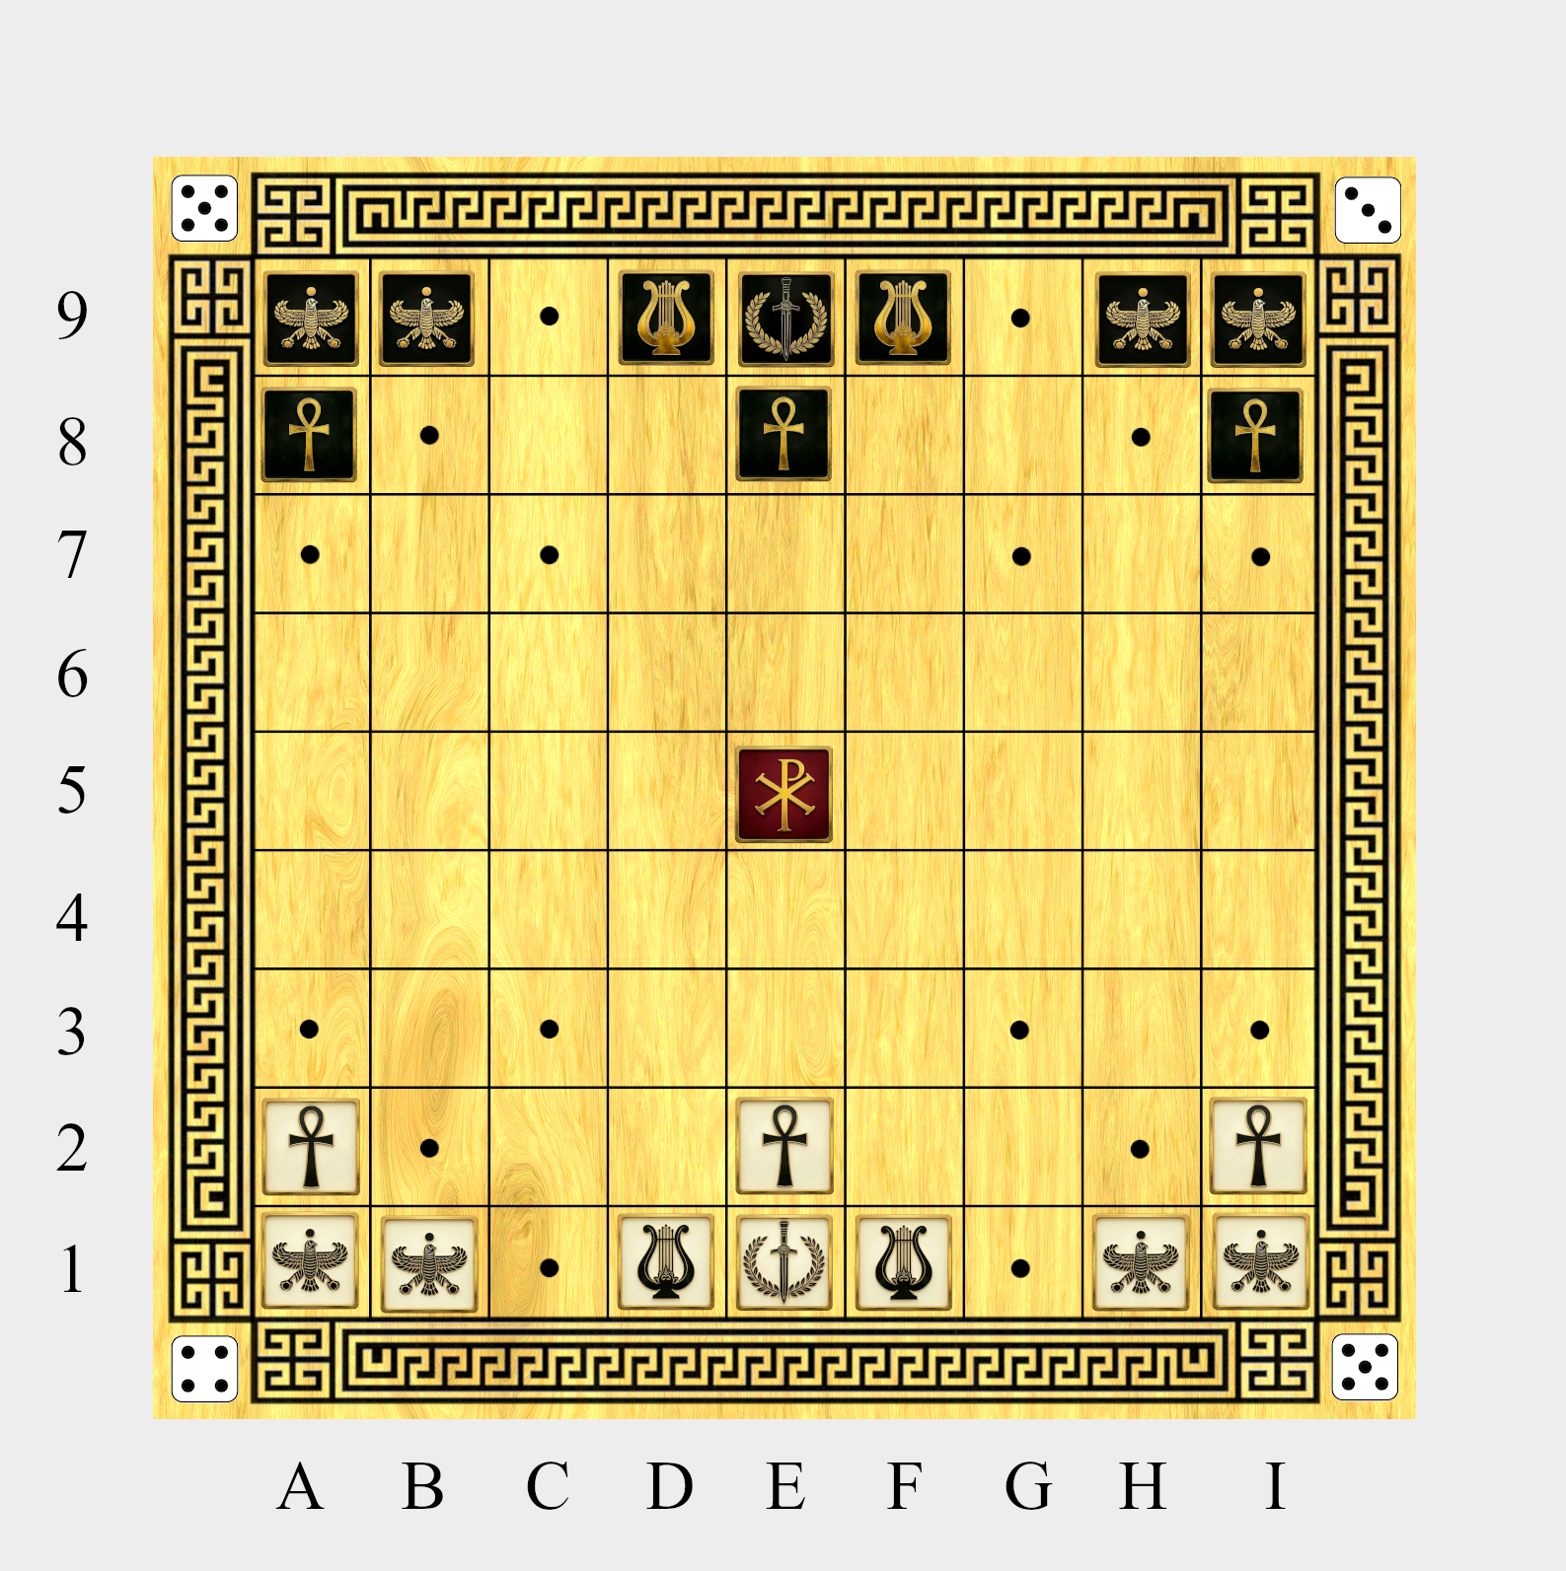
Moving to an unoccupied square: Movement is turn-based and begins with White making the first move. All game pieces, including the Vicar, must move according to group patterns that are found in any current game position. A pattern consists of pieces of the same colour linking at adjacent squares. A single game piece which is not part of a group has no pattern. All moves must be along unobstructed paths.
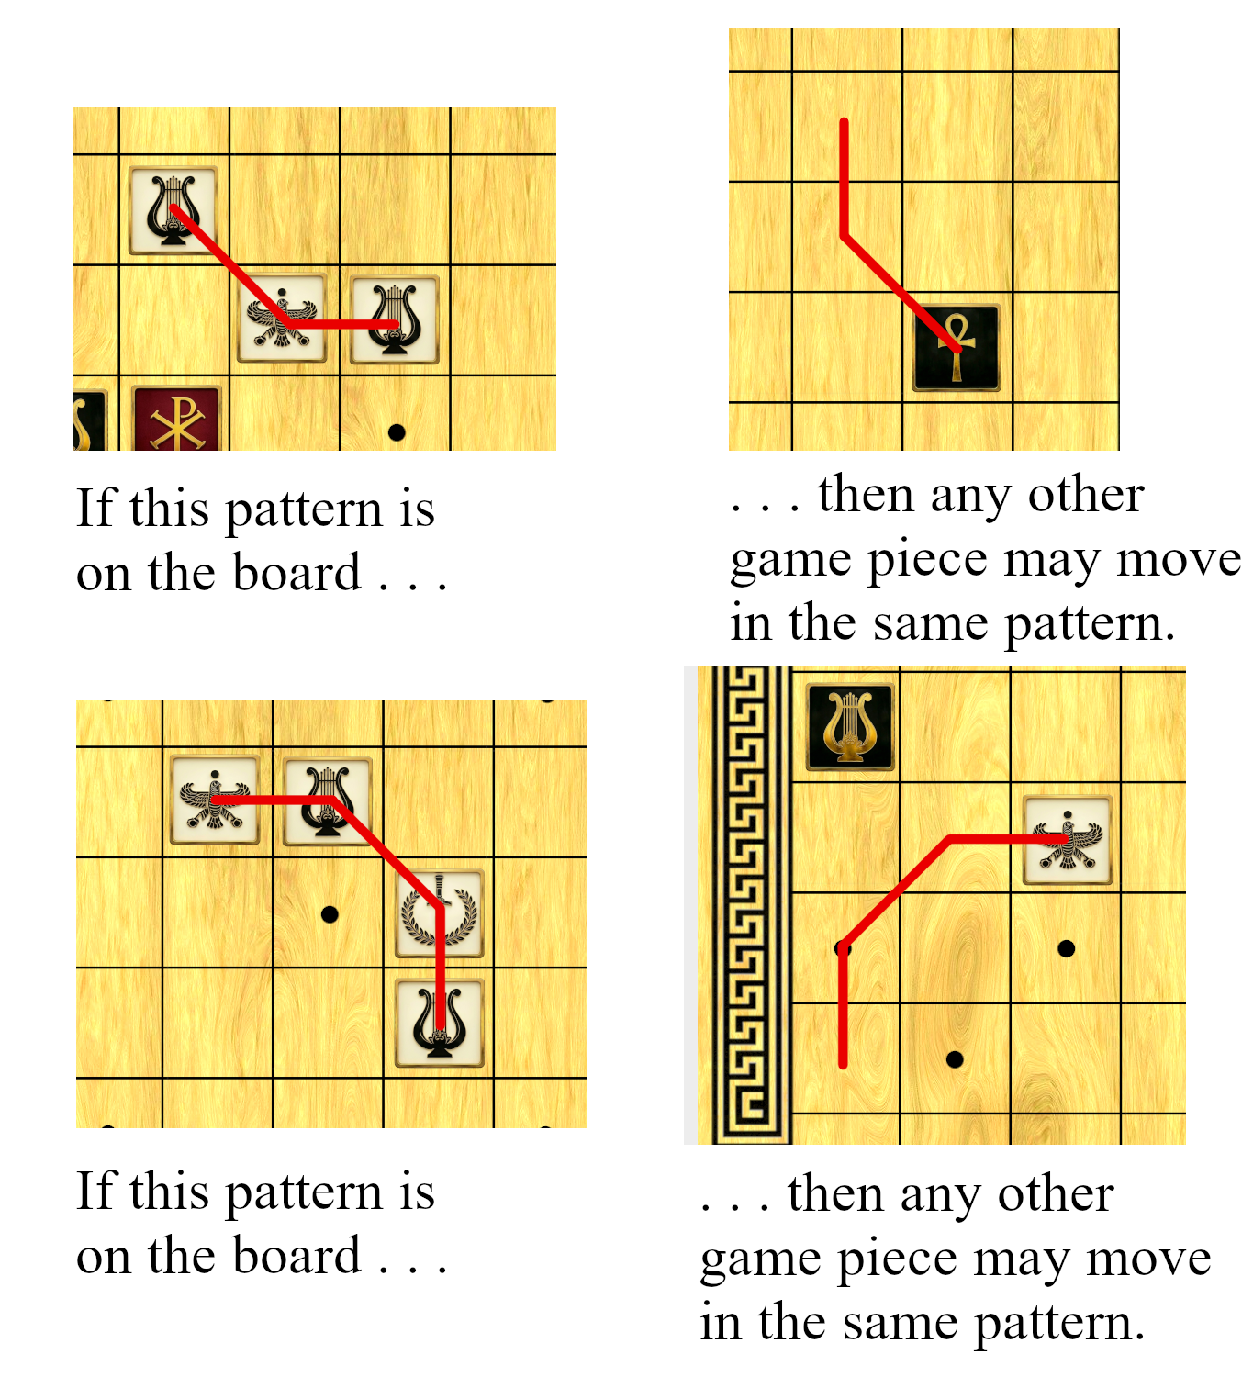
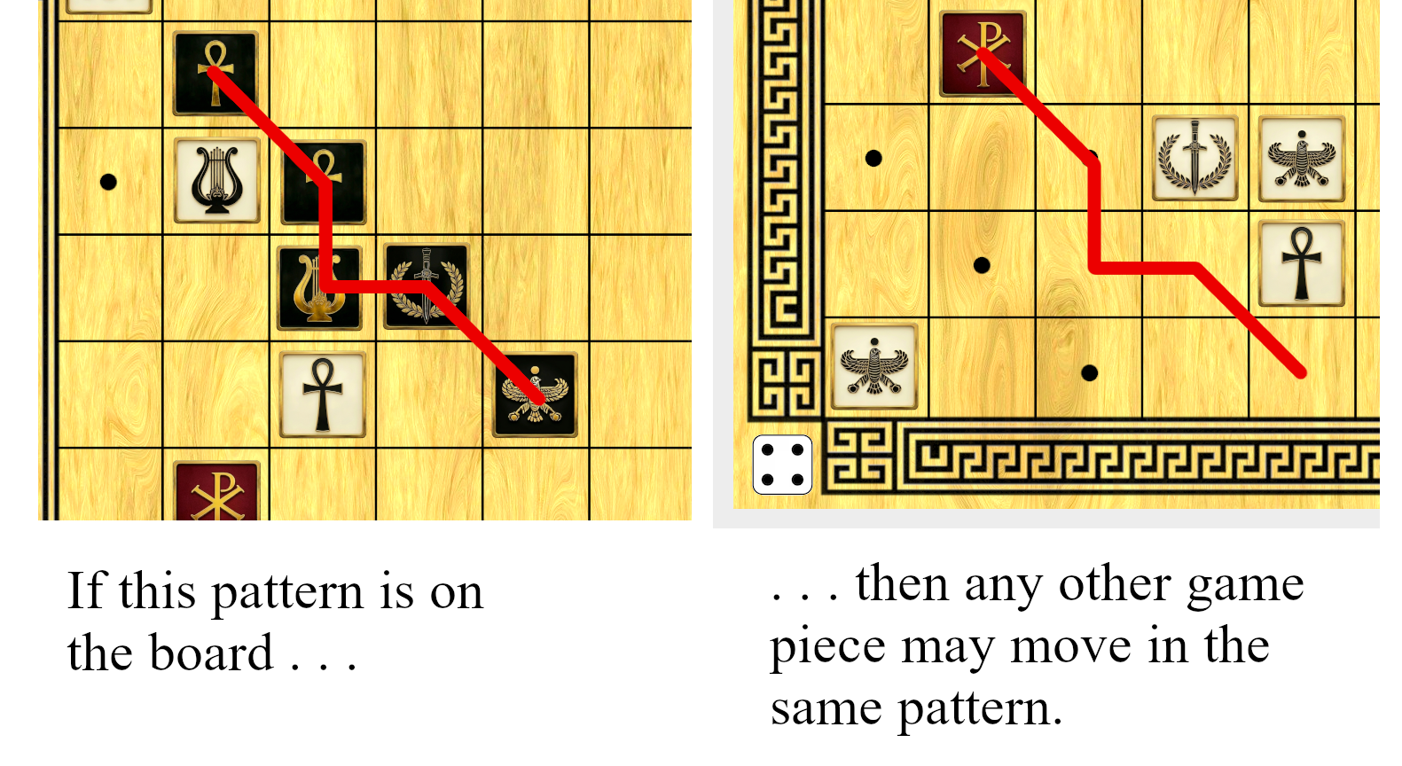
This movement rule allows for game pieces to zigzag around opponents or even wrap around to the other side of a certain square. Any patterns found in the current game position may be rotated or flipped as long as the basic pattern is still intact. Any game piece moving along a path to a vacant square must move along an unobstructed path (a game piece may never leap over any game piece on the board).
Clusters: Usable patterns are only positions which allow for a linear path that does not repeat across any square. Some patterns do not allow for this and therefore cannot be used. Unusable patterns are called clusters.
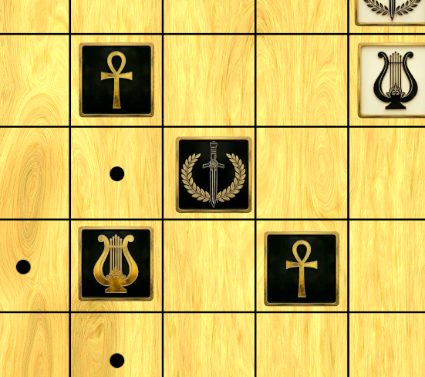 | Black’s pattern here is a cluster since there is no linear path possible that will not repeat the square occupied by Black’s Caesar.

Sacking (moving to an occupied square): Moving to an occupied square to remove a game piece from the playing area is called a sack. A game piece executing a sack does not move according to found patterns. A sacking game piece may only move along an unobstructed path either along a rank or file or along a diagonal. The distance a game piece may sack is exactly the number equal to the size of the group the sack is coming from. Four conditions must exist. 1) The game piece must sack from a distance of two or more 2) The game piece must be of a stronger suit 3) if the suit is the same then the sacking player must be coming from a larger group and 4) the Vicar must have a legal move according to the available patterns on the board existing after the sack has been executed (the Vicar is awarded a move immediately following the sack). The Vicar, while the most valuable game piece, cannot sack. Suit strength is in the following order: 1) Caesar 2) Emperor 3) Pharaoh 4) Shah with Caesar having the highest value and the Shah having the least value. The Vicar may never be sacked.
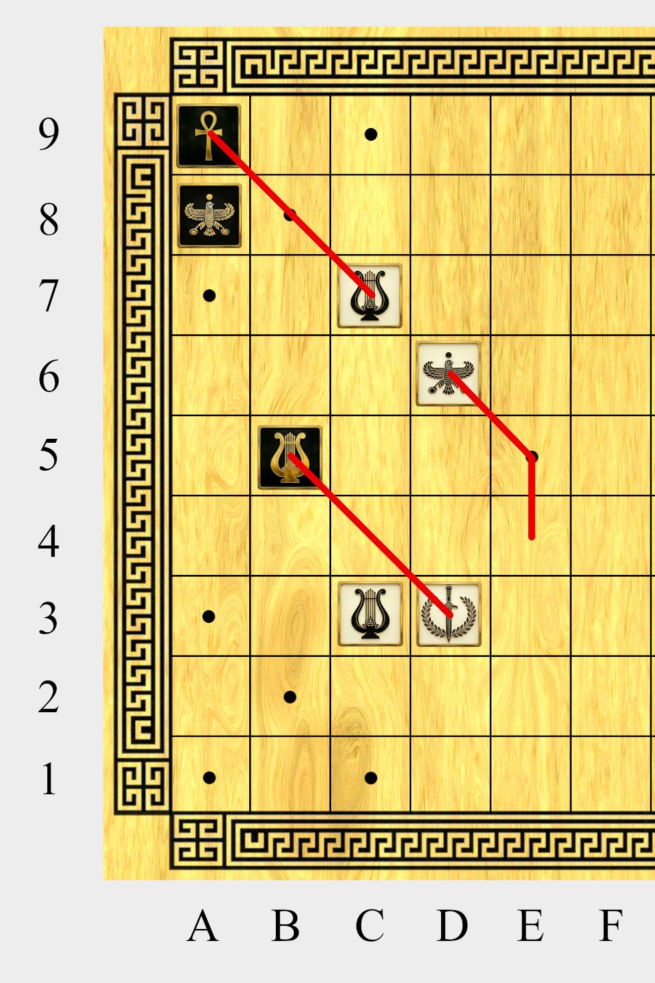
The above diagram is an example of a double attack. White moved his Shah from e4 where it formed the pattern that was used to move to d6. This move changed the attacking distance of White’s Caesar on d3 from 3 to 2 so that it is now attacking Black’s Emperor on b5. Furthermore, the move increased the attacking distance of White’s Emperor on c7 so that it is now attacking Black’s Pharaoh on a9.
Vicar: After a sack is executed, and as part of the same turn, the Vicar game piece must be moved by the player who executed the sack. If the Vicar is in a grid he may choose to move at the distance indicated on that grid’s die. (SEE GRIDS) The Vicar may only move along an unobstructed path. If there is no move possible for the Vicar, the sack was illegal and must be taken back.
The River and the Die: The middle rank of the board which divides the territories is called the river. Whenever a player enters the Vicar into the territory of the enemy from the river or from his own territory, he may adjust any one of the four dice if he so chooses. The die chosen must be increased or decreased by an increment of 1 (a six may only be decreased to five and a one may only be increased to two).
Three-step Turn: So when a player sacks, he must then move the Vicar and, after moving the Vicar, he may—should he have moved into his enemy’s territory from the river or from his own territory—adjust one of the four dice by an increment of one—all of these steps executed in one turn with the last dice-adjustment step as optional.
Placement: If sacked, the player whose piece was sacked must use his next turn to place the piece back on the board. This placement occurs after the sacker ends his turn. The sacked game piece must be re-entered upon only one vacant square upon the board: the square the Vicar had last occupied. Once the placement is complete, the player’s turn ends.
Grids: Each 3 X 3 area in each corner of the board marked with five pips is called a grid. When any game piece, including the Vicar, is within a grid, that game piece has the option of moving the distance indicated on the die regardless of the size of the group the game piece is in. When a game piece moves according to the die it may not sack another piece and must only move in a straight line along a diagonal or along a rank or file.
Significance of the Design: Pards synthesizes cards, chess and dice. The common approach of ranking cards so that higher numbers have more value within the same suit is used in Pards. The game also uses dice to acquire asymmetry and to avoid over analysis of the opening. Moreover, since the material is sustained throughout the game, there is no point where a solvable endgame is reached; this makes the game AI-resistant and therefore eliminates AI-assisted cheating as a problem for Pards tournaments.
Learn more at www.lipards.org

